22.59: a) 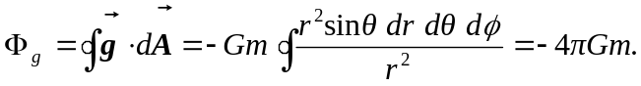

b) For any closed surface, mass OUTSIDE the surface contributes zero to the flux passing through the surface. Thus the formula above holds for any situation where is the mass enclosed by the Gaussian surface.
That is: